EXPERIMENT 4: AM SUPERHETERODYNE / IF SIGNAL ANALYSIS

1. AIM
To generate an AM signal, mix it with a local oscillator to obtain an intermediate frequency (IF) signal, and recover the original message signal using envelope detection in MATLAB.

2. APPARATUS / SOFTWARE REQUIRED
- Computer or laptop
- MATLAB software
- MATLAB Editor for entering and running the program

3. THEORY
In this experiment, an AM signal is generated using a message signal and a carrier signal. The AM signal is then multiplied with a local oscillator signal to perform frequency mixing. An IF filter is used to obtain the intermediate-frequency component. The recovered signal is then obtained using envelope detection based on the analytic signal.
Given parameters:
Message frequency, fm = 500 Hz
Carrier frequency, fc = 10000 Hz
Local oscillator frequency, fLO = 14550 Hz
Intermediate frequency, IF = 14550 − 10000 = 4550 Hz

4. MATLAB CODE
clc;
clear;
close all;
% Parameters
fs = 100000;
t = 0:1/fs:0.02;
fm = 500; % Message frequency
fc = 10000; % Carrier frequency
fLO = 14550; % Local Oscillator (IF = 4550 Hz)
% Message Signal
m = cos(2*pi*fm*t);
% Carrier Signal
c = cos(2*pi*fc*t);
% AM Signal
am = (1 + m).*cos(2*pi*fc*t);
% Local Oscillator
LO = cos(2*pi*fLO*t);
% Frequency Mixing
mixed = am .* LO;
% IF Filter
[b,a] = butter(4,5000/(fs/2));
IF = filter(b,a,mixed);
% Envelope Detection
env = abs(hilbert(IF));
% Display
figure;
subplot(4,1,1)
plot(t,m)
title('Message Signal')
grid on
figure;
subplot(5,1,2)
plot(t,c)
title('Carrier Signal')
grid on
subplot(5,1,3)
plot(t,am)
title('AM Signal')
grid on
subplot(5,1,4)
plot(t,IF)
title('Intermediate Frequency (IF) Signal')
grid on
subplot(5,1,5)
plot(t,env)
title('Recovered Signal')
grid on

5. MATLAB OUTPUT
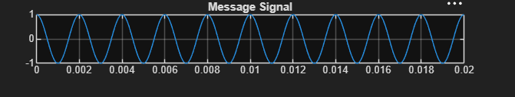
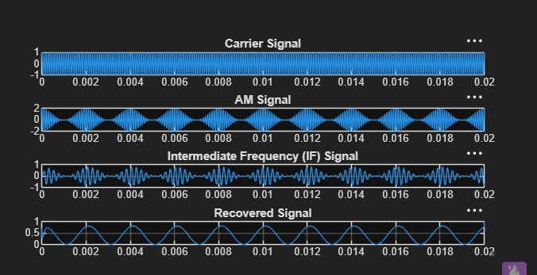
The output shows the message signal, carrier signal, AM signal, intermediate-frequency (IF) signal, and recovered signal.

6. RESULT
The AM signal was generated successfully and mixed with the local oscillator. The intermediate-frequency signal was obtained using the IF filter, and the message was successfully recovered using envelope detection.

